HOME

ALL YOUR LOAN NEEDS MADE SIMPLER ,EASY AND FAST!

All you need is a whatsap app.

Use credit risk logo.. -on the right

THE SMART CHOICE

Who we are:

We are a leading fintech firm headquartered in Kenya, leveraging cutting-edge AI technology to deliver short-term financing solutions, extending up to 30 days, to both individuals and businesses.

Utilizing the ubiquitous WhatsApp platform, we offer swift and adaptable loan services to our esteemed clientele with the simple action of initiating a conversation with our AI-powered assistant.

Streamlining the lending process, we have eliminated the need for cumbersome paperwork, requiring only a valid ID and M-Pesa statement for verification.

With a commitment to providing timely assistance, funds are disbursed instantly to your M-Pesa account, ensuring prompt access to financial support when needed.

Experience seamless growth with us through a single click, as timely repayments foster a symbiotic relationship, enabling us to progressively enhance your borrowing capabilities

OUR SERVICES

We offer a minimum of 3000 ksh to a maximum of 50,000

OUR JOURNEY

Use credit risk journey chart flow below…

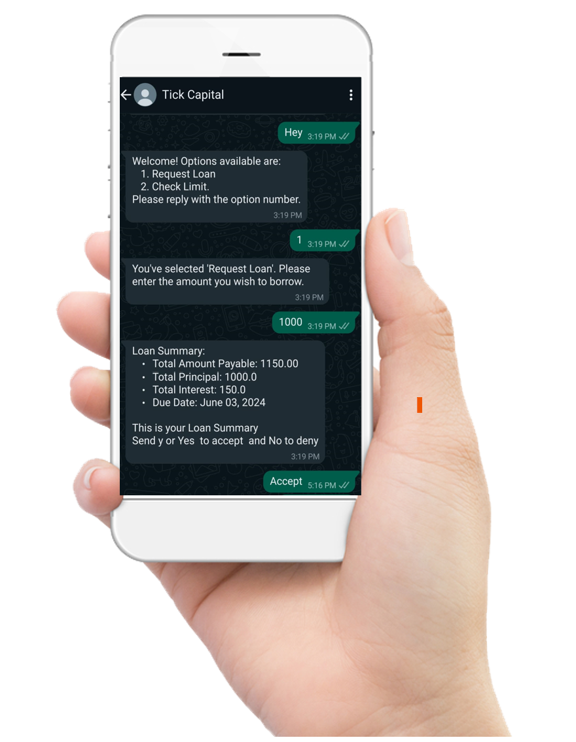

## Privacy is paramount

##### **At credit risk the privacy and security of our customers and their data is our top priority.**

https://d2c5ectx2y1vm9.cloudfront.net/assets/hiw/privacy_icon_1-4a2cac5f232cdd7f39d3860809bbbc35c29c66589856247fd67edb75a1d4303e.png

### **Security**

All the data we use is encrypted and protected.

We have strict policies in place that ensure our methods are properly communicated and customer data is always secure.

https://d2c5ectx2y1vm9.cloudfront.net/assets/hiw/privacy_icon_2-1015aaf2f40c745a963afe426a7efb2238d0ccaad90da49b58702f71a4dee733.png

### **Data privacy**

We never sell customer data or share customer contacts with third parties.

https://d2c5ectx2y1vm9.cloudfront.net/assets/hiw/privacy_icon_3-2b07888d698fb809e55a693db8e0ab4e6b7e13de23cf2f00cfd43a5cfde69e7f.png

### **Ethical collections**

We do not condone any aggressive debt collection practices, including debt shaming.

If you experience any form of harassment, please report the issue to us immediately via in-app chat.

CONTACTS

Mobile :0718499482

Phone: 0720862220

Email: Customer@tickconsulting.co.ke